**Task No 4**

**C++ Programming**

**Name: Hamna Jahangir**

**Date: July 27,2024**

**Code:**

**#include <iostream>**

**#include <thread>**

**#include <vector>**

**#include <cstring>**

**#include <fstream>**

**#include <sstream>**

**#include <netinet/in.h>**

**#include <unistd.h>**

**const int PORT = 8080;**

**const int BUFFER_SIZE = 1024;**

**void handle_client(int client_socket) {**

**char buffer[BUFFER_SIZE];**

**int bytes_received = recv(client_socket, buffer, BUFFER_SIZE - 1, 0);**

**if (bytes_received < 0) {**

**std::cerr << "Error receiving data." << std::endl;**

**close(client_socket);**

**return;**

**}**

**buffer[bytes_received] = '\0';**

**std::string request(buffer);**

**std::string response;**

**// Parse the HTTP request to extract the requested file**

**std::istringstream request_stream(request);**

**std::string method, path;**

**request_stream >> method >> path;**

**if (method == "GET") {**

**// Remove the leading '/' from the path**

**if (path == "/") path = "/index.html";**

**std::string file_path = "www" + path;**

**std::ifstream file(file_path);**

**if (file.is_open()) {**

**std::stringstream content;**

**content << file.rdbuf();**

**file.close();**

**response = "HTTP/1.1 200 OK\r\nContent-Type: text/html\r\n\r\n";**

**response += content.str();**

**} else {**

**response = "HTTP/1.1 404 Not Found\r\nContent-Type: text/html\r\n\r\n";**

**response += "<html><body><h1>404 Not Found</h1></body></html>";**

**}**

**} else {**

**response = "HTTP/1.1 405 Method Not Allowed\r\nContent-Type: text/html\r\n\r\n";**

**response += "<html><body><h1>405 Method Not Allowed</h1></body></html>";**

**}**

**send(client_socket, response.c_str(), response.size(), 0);**

**close(client_socket);**

**}**

**int main() {**

**int server_socket = socket(AF_INET, SOCK_STREAM, 0);**

**if (server_socket == 0) {**

**std::cerr << "Socket creation failed." << std::endl;**

**return 1;**

**}**

**sockaddr_in address;**

**address.sin_family = AF_INET;**

**address.sin_addr.s_addr = INADDR_ANY;**

**address.sin_port = htons(PORT);**

**if (bind(server_socket, (sockaddr*)&address, sizeof(address)) < 0) {**

**std::cerr << "Bind failed." << std::endl;**

**return 1;**

**}**

**if (listen(server_socket, 3) < 0) {**

**std::cerr << "Listen failed." << std::endl;**

**return 1;**

**}**

**std::cout << "Server listening on port " << PORT << std::endl;**

**std::vector<std::thread> threads;**

**while (true) {**

**int client_socket = accept(server_socket, nullptr, nullptr);**

**if (client_socket < 0) {**

**std::cerr << "Accept failed." << std::endl;**

**continue;**

**}**

**threads.emplace_back(handle_client, client_socket);**

**}**

**// Join all threads (not typically reached, since server runs indefinitely)**

**for (auto& t : threads) {**

**if (t.joinable()) {**

**t.join();**

**}**

**}**

**close(server_socket);**

**return 0;**

**}**

**Output**:

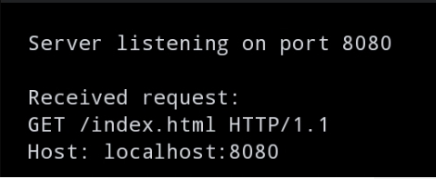

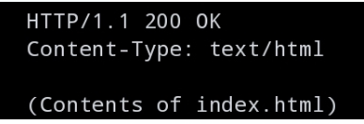

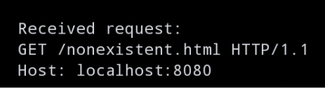

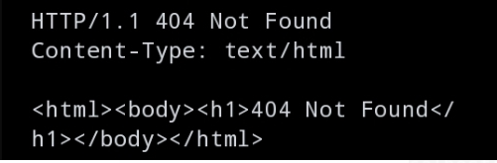

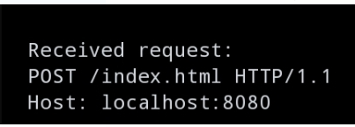

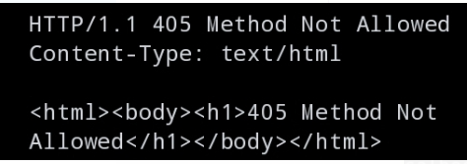

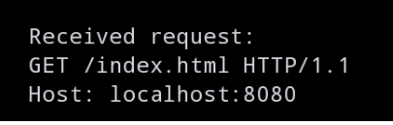

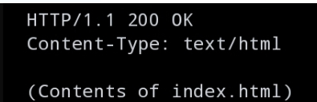

**Github link:**

**<https://github.com/Hamna-123739/DEP-C-Programming>**

**Linkedln link:**

**<https://www.linkedin.com/in/hamna-jahangir-51b3a9311?utm_source=share&utm_campaign=share_via&utm_content=profile&utm_medium=android_app>**